

Star club bojových umení
Európska trieda 2507/11
040 13 Košice

VEC: Povolenie na uskutočnenie skúšky technickej vyspelosti

Povoľujem vykonať skúšky technickej vyspelosti

Páskovanie:
Miesto: Poľná 1, 040 14 Košice
Dátum: 27/06/2026; 13:30
Komisia: Martin Suchý, 4. DAN; Tomáš Kamenca, 3. DAN

P.č.: | Priezvisko | Meno | Dátum posl. STV | Aktuálny stupeň | Nový stupeň | Poznámka
1. | Paľa | Matteo | - | 10 GUP | 9 GUP | ok
2. | Pastierik | Juraj | - | 10 GUP | 9 GUP | ok
3. | Rusnaková | Adela | - | 10 GUP | 9 GUP | ok
4. | Raganová | Alena | - | 10 GUP | 9 GUP | ok
5. | Sándorová | Ella | 30.03.2026 | 9 GUP | 8 GUP | ok
6. | Marcinčák | Andrej | 28.06.2025 | 9 GUP | 8 GUP | ok
7. | Juračová | Hanna | 23.01.2026 | 9 GUP | 8 GUP | ok
8. | Panda | Michal | 01.02.2025 | 9 GUP | 8 GUP | ok
9. | Jarabek | Lukáš | 26.11.2025 | 9 GUP | 8 GUP | ok
10. | Ťuchová | Emília | 28.06.2025 | 9 GUP | 8 GUP | ok
11. | Marcinčák | Juraj | 26.11.2025 | 9 GUP | 8 GUP | ok
12. | Macík | Štefan | 23.01.2025 | 9 GUP | 8 GUP | ok
13. | Buchta | Dušan | 26.11.2025 | 9 GUP | 8 GUP | ok
14. | Džunko | Simon | 26.11.2025 | 9 GUP | 8 GUP | ok
15. | Ružička | Patrik | 26.11.2026 | 9 GUP | 8 GUP | ok
16. | Seliga | Michal | 26.11.2025 | 9 GUP | 8 GUP | ok
17. | Ragan | Róbert Filip | 26.11.2025 | 9 GUP | 8 GUP | ok
18. | Džunko | Marko | 26.11.2025 | 9 GUP | 8 GUP | ok
19. | Hrehová | Lenka | 30.03.2026 | 9 GUP | 8 GUP | ok
20. | Illés | Daniel | 23.01.2026 | 8 GUP | 7 GUP | ok
21. | Mihok | Matthias | 23.01.2026 | 8 GUP | 7 GUP | ok
22. | Ťuch | Oliver | 23.01.2026 | 8 GUP | 7 GUP | ok
23. | Liptáková | Veronika | 23.01.2026 | 8 GUP | 7 GUP | ok
24. | Ragányová | Daniela | 23.01.2026 | 8 GUP | 7 GUP | ok
25. | Mihok | Vivien | 26.11.2025 | 8 GUP | 7 GUP | ok
26. | Fedorčák | Adam | 23.01.2026 | 7 GUP | 6 GUP | ok
27. | Derian | Damián | 23.01.2026 | 7 GUP | 6 GUP | ok
28. | Mochnáčová | Simona | 23.01.2026 | 7 GUP | 6 GUP | ok
29. | Mochnáč | Timon | 23.01.2026 | 7 GUP | 6 GUP | ok
30. | Mochnáč | Ivan | 23.01.2026 | 7 GUP | 6 GUP | ok
31. | Kocka | Peter | 30.03.2026 | 6 GUP | 5 GUP | ok
32. | Petrik | Sebastián | 23.03.2026 | 6 GUP | 5 GUP | ok
33. | Kováčová | Miriam | 23.01.2026 | 6 GUP | 5 GUP | ok
34. | Derian | Marko | 23.01.2026 | 6 GUP | 5 GUP | ok
35. | Petriková | Sofia | 23.01.2026 | 6 GUP | 5 GUP | ok
36. | Rešetár | Adrian | 30.03.2026 | 6 GUP | 5 GUP | ok
37. | Diržininkas | Dominik | 30.03.2026 | 6 GUP | 5 GUP | ok
38. | Kapsiar | Michal | 23.01.2026 | 6 GUP | 5 GUP | ok
39. | Kajatyová | Natália | 23.01.2026 | 6 GUP | 5 GUP | ok
40. | Marhulíková | Nina | 23.01.2026 | 6 GUP | 5 GUP | ok
41. | Tothová | Kristína | 23.01.2026 | 5 GUP | 4 GUP | ok
42. | Marčišin | Marko Ján | 23.01.2026 | 5 GUP | 4 GUP | ok
43. | Vojtaníková | Lenka | 28.06.2025 | 5 GUP | 4 GUP | ok
44. | Ragány | Tomáš | 23.01.2026 | 4 GUP | 3 GUP | ok
45. | Jakubec | Christian | 23.01.2026 | 4 GUP | 3 GUP | ok
46. | Ragány | Peter | 23.01.2026 | 4 GUP | 3 GUP | ok
47. | Hančáková | Laura | 23.01.2026 | 2 GUP | 1 GUP | ok
48. | Barča | Max | 23.01.2026 | 2 GUP | 1 GUP | ok
49. | Jarabeková | Lea | 22.02.2026 | 2 GUP | 1 GUP | ok
50. | Barča | Ján | 23.01.2026 | 2 GUP | 1 GUP | ok

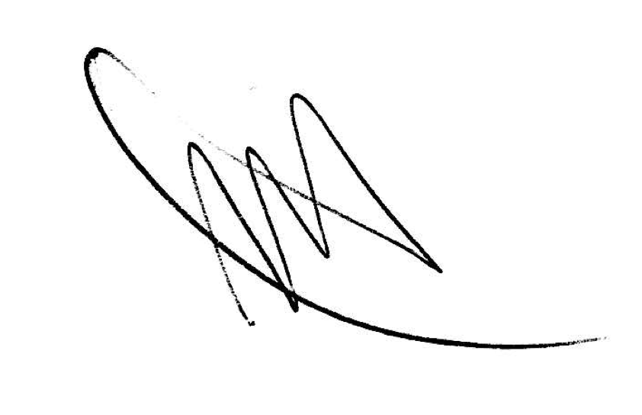

Bc. Miroslava Matejková, matrikár SATKD WT

V Bratislave, 24.6.2026

